Installation and Configuration of GeoServer

GeoServer Install
03 January 2009



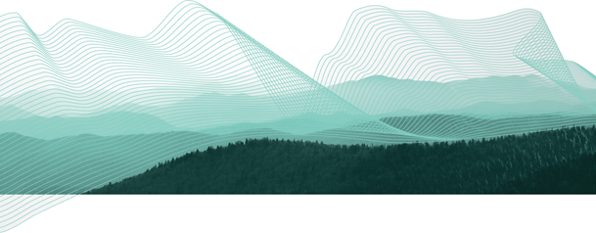

Table of Contents
1 Goals 3
2 Java Development Kit Install: 4
3 Set JAVA_HOME 6
4 GeoServer install 7
5 Starting up GeoServer 10
6 WFS-T Demo 13
7 Things to Explore 15

Goals
After completing this workbook, you will have:
- Installed a Java Development Kit onto your computer
- Installed GeoServer using the Windows installer
- Started up and Customize GeoServer
- Started the Open Layers WFS-T Demonstrate

Java Development Kit Install:
- Download the latest Java SE Development Kit from sun:
http://java.sun.com/javase/downloads/
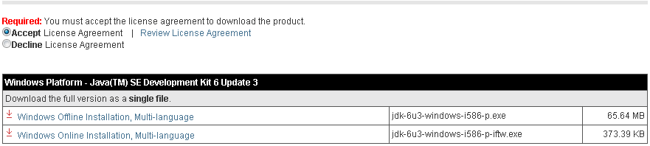
- Double-click the installer (jdk-6u3-windows-i586-p.exe is used in this example) and accept the license agreement.
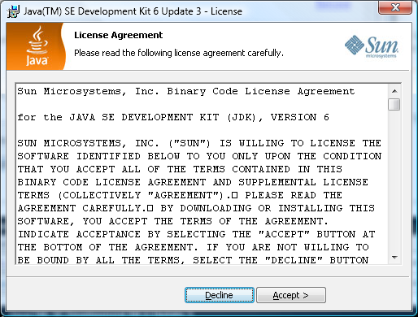
- Note: You don’t have to install either the Demos or Public Runtime Environment.
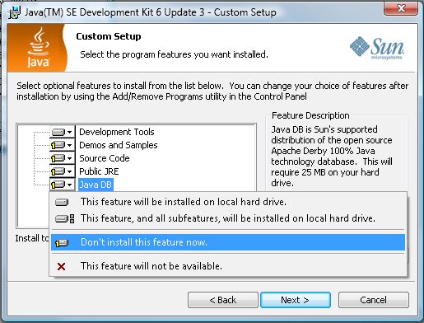
- This will create the following directory:
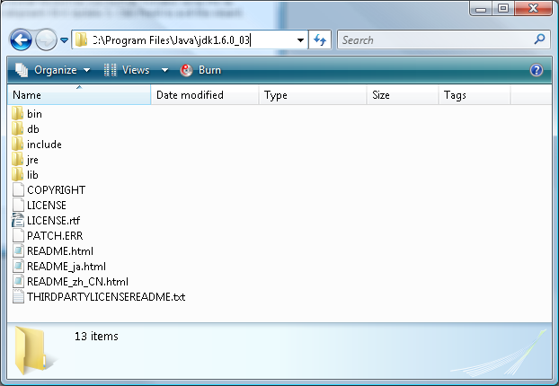

Set JAVA_HOME
- Right click on the My Computer icon on your desktop and select Properties from the drop down menu. Under the Advanced tab click the Environment Variables... button.
- Press the New button under System Variables to create the following:
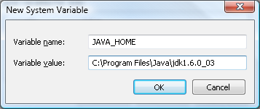
- The lis of environmental variables now points JAVA_HOME to your installation directory.
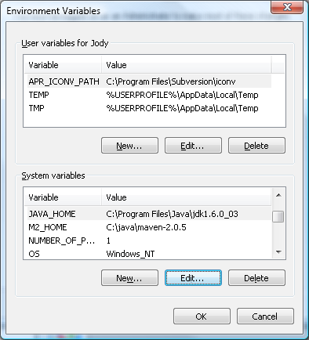

GeoServer install
- Downloaded the latest GeoServer release:
http://docs.codehaus.org/display/GEOS/Download
- Double-click the geoserver-1.6.4.exe installer.
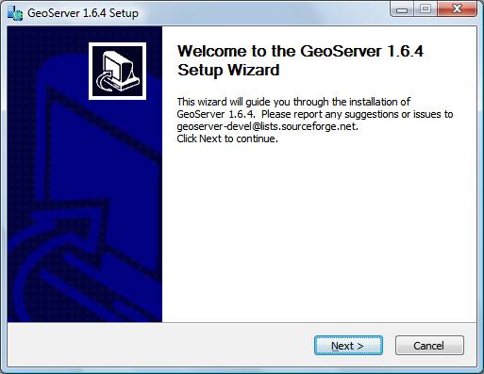
- Press Next, ensure GeoServer discovers the JDK installed previously.
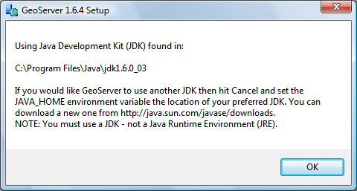
- GeoServer is a GPL application, press “I Agree” to continue.
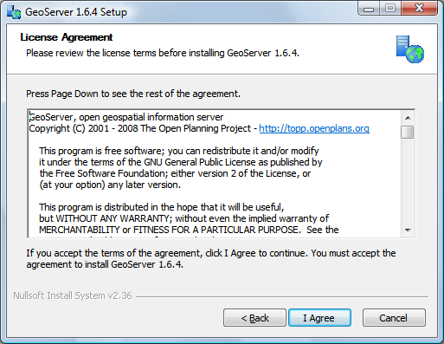
- GeoServer will install into the Programmers Files directory, press Next to continue.
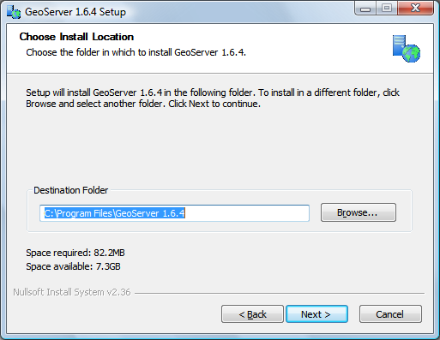
- GeoServer will store your configuration in a “data directory”, the default location will work fine. Press Next to continue.
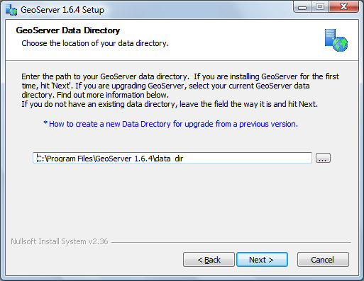
- Press Next to create the default start menu folder
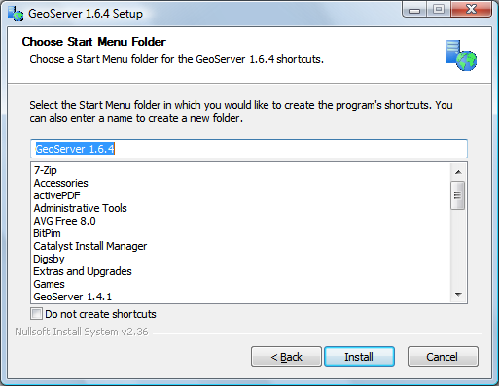
- Please wait while the application installs.
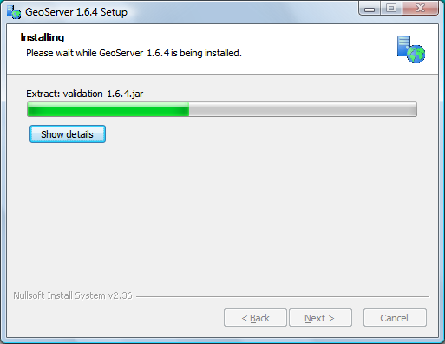
- Congratulations, press Finish to exit the installer.
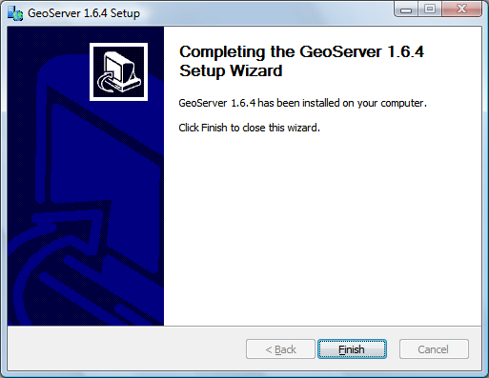

Starting up GeoServer
In this section you will learn how to start GeoServer, and explore its editing abilities.
- Click Start->Programs >GeoServer 1.6.4 >Start GeoServer
If you have a web server already running on port 8080 you can change the jetty.xml file by hand.
- GeoServer will open up a console running the Jetty Application Server; please wait until Jetty indicates it is listening on port 8080 as shown below.
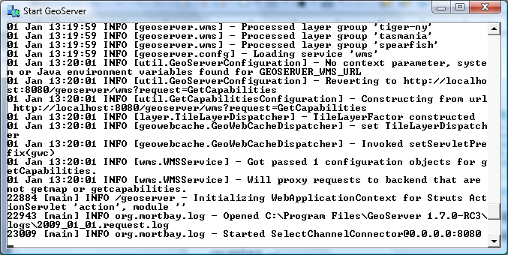
- Open up a web browser and enter the URL: http://localhost:8080/geoserver
- We need to login before we can use the configuration screen. Click on the “Login” link in the upper right corner.
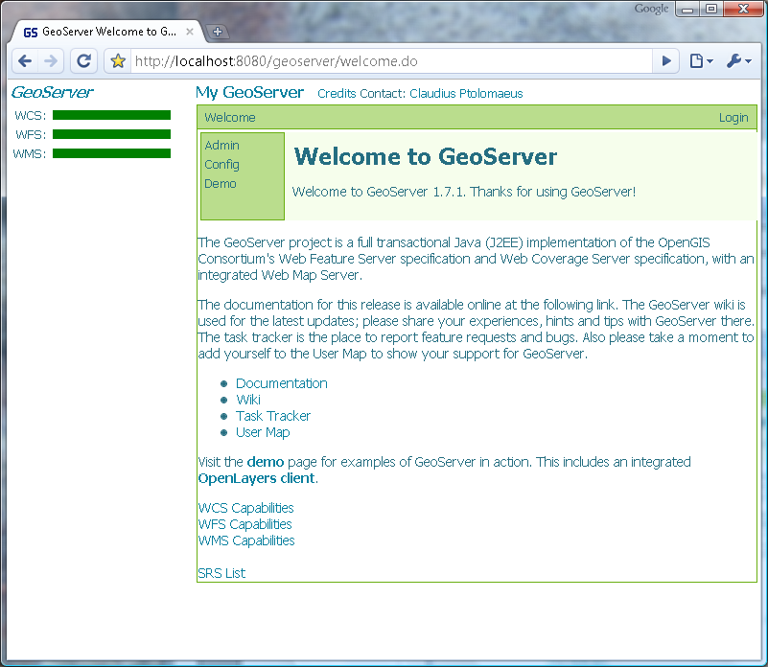
- Login using “admin” and “geoserver” as the credentials.
- Press Submit to return to the welcome screen. You can now press “Config” to begin customizing GeoServer.
- Continue deeper into the configuration system by pressing “WMS” and then “Description”. As you navigate you can see where you are along the top of the screen. Please take a moment to change the title of your WMS Service.
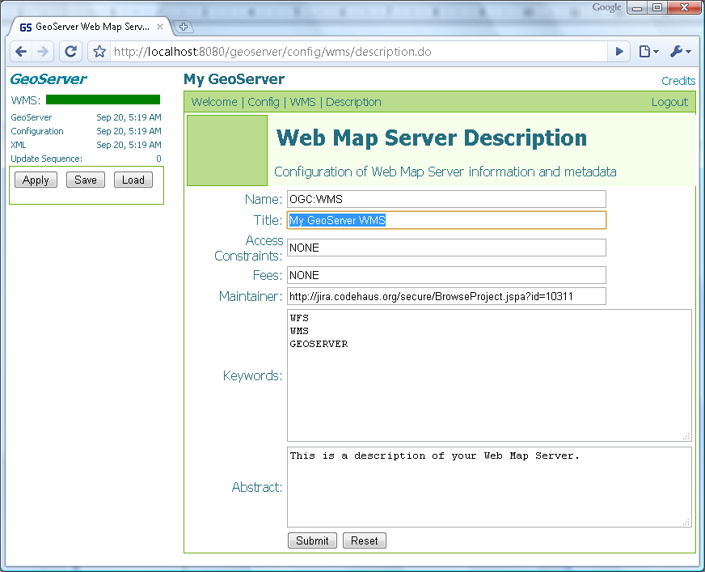
- Press the “Apply” button in the top left corner.
(this allows you to try out the settings without saving)
- You can see that you have unsaved changes as the date has changed next to “GeoServer*”. This section of the screen shows how healthy your server is. The fact that we have a green bar shows that everything is working.
- Pressing the “Save” button will save your changes into the data directory specified during the installation.

WFS-T Demo
One of the things that makes GeoServer a capable Web Feature Server is the ability to edit (The “T” is for transactional in WFS-T).
- Return to the “Welcome” screen and select “Demo”
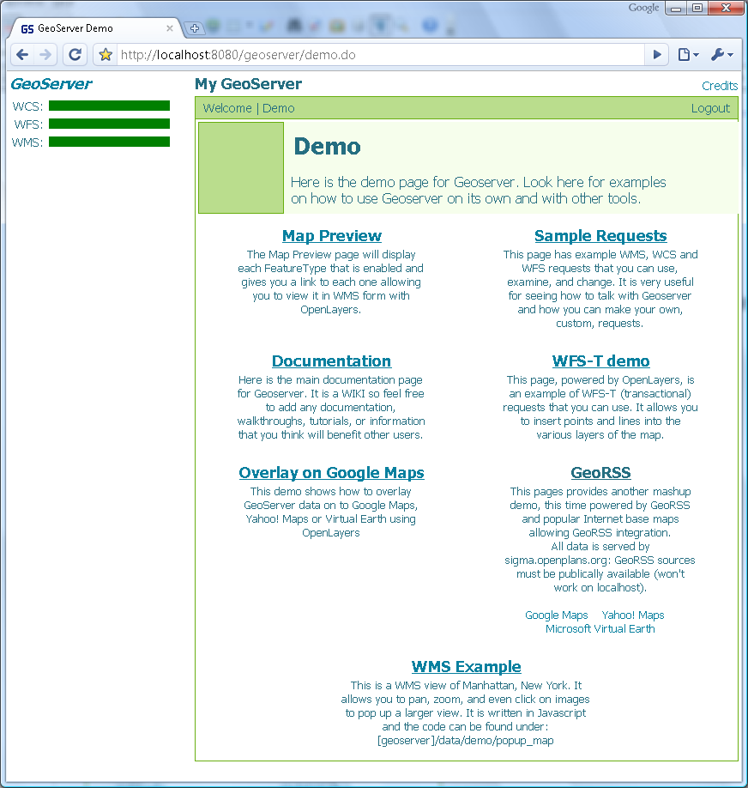
- Click on the “WFS-T demo” to open a new tab. As this Open Layers application is started up you can watch the GeoServer console respond to queries.
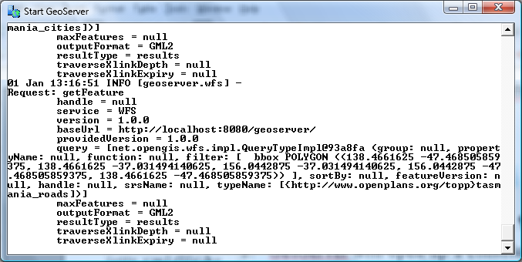
- This will bring up a web application put together with “Open Layers”.
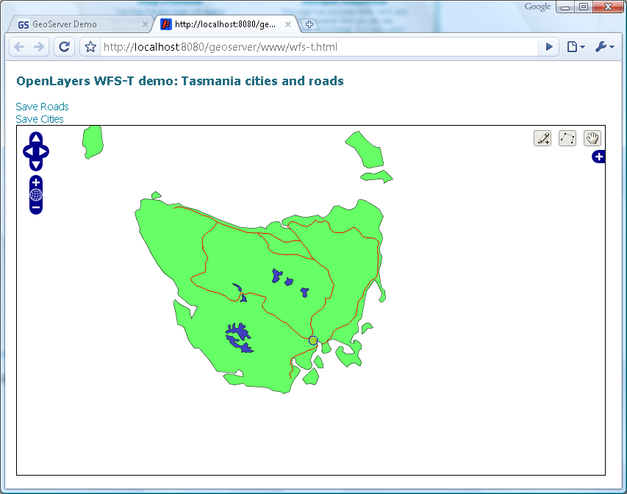
This is the same map used as a reference point for the uDig “Walkthrough 2” tutorial.
- You can use the point and line tools to draw additional roads and cities onto the map. The links at the top of the page can be used to submit your work to GeoServer.
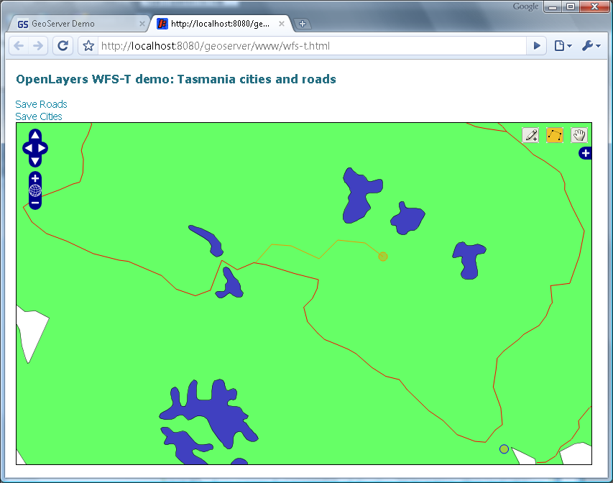

Things to Explore
If you finish early here are some challenges.
- Try out some of the others demos
- The “Sample Requests” demo lets you try out requests one at a time by selecting them from a List and hitting Send. Try out a GetMap request by hand.
Remember you can hit “Apply” to try out your settings. If you do not like them you can hit “Load” to reset the configuration to the last time saved.
- Config > Server
You can fill in your contact details here, and turn down the amount of logging to let GeoServer run faster
- Config > WMS > Rendering
Turn off anti aliasing for a speed boost.
- Config > Data > DataStores
Register new shape files and data bases. You can use the same PostGIS database from uDig walkthrough 1.
- Config > Data > FeatureTypes
Publish select FeatureTypes from your DataStores
- Config > Data > Style
Control the rendering of specific FeatureTypes
How can you use GeoServer in your organization?

